Airbnb Price Prediction using Big Data Analytics

The first city I have chosen is:
Barossa Valley, South Australia, Australia
S1. A plot of variables using the display() command in data bricks.
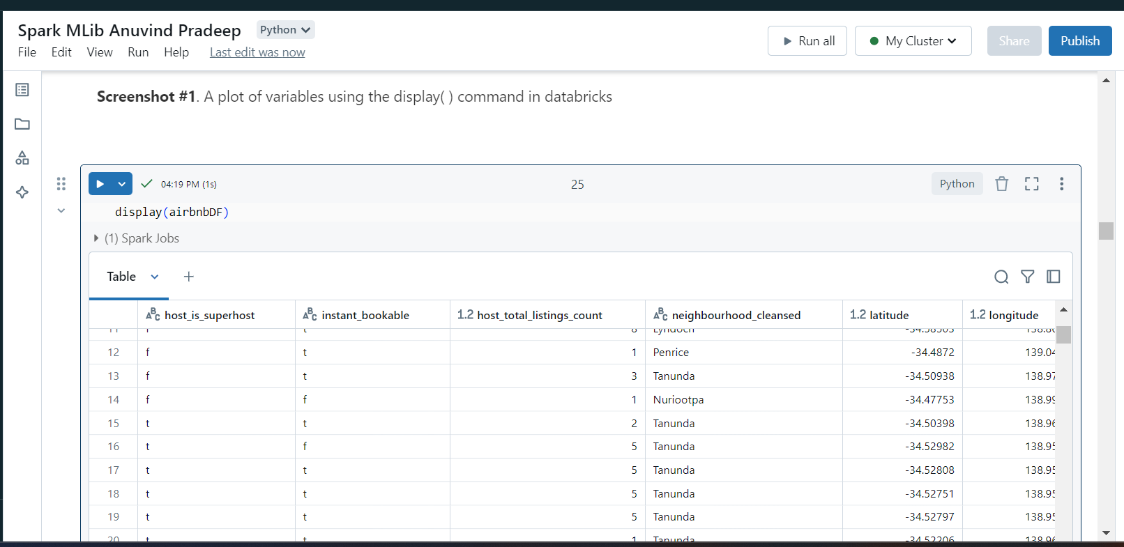
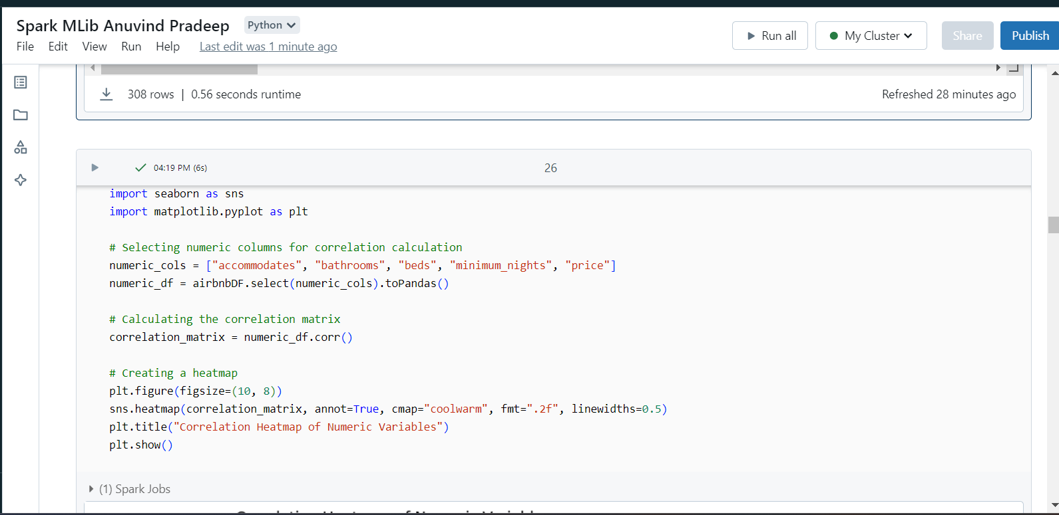
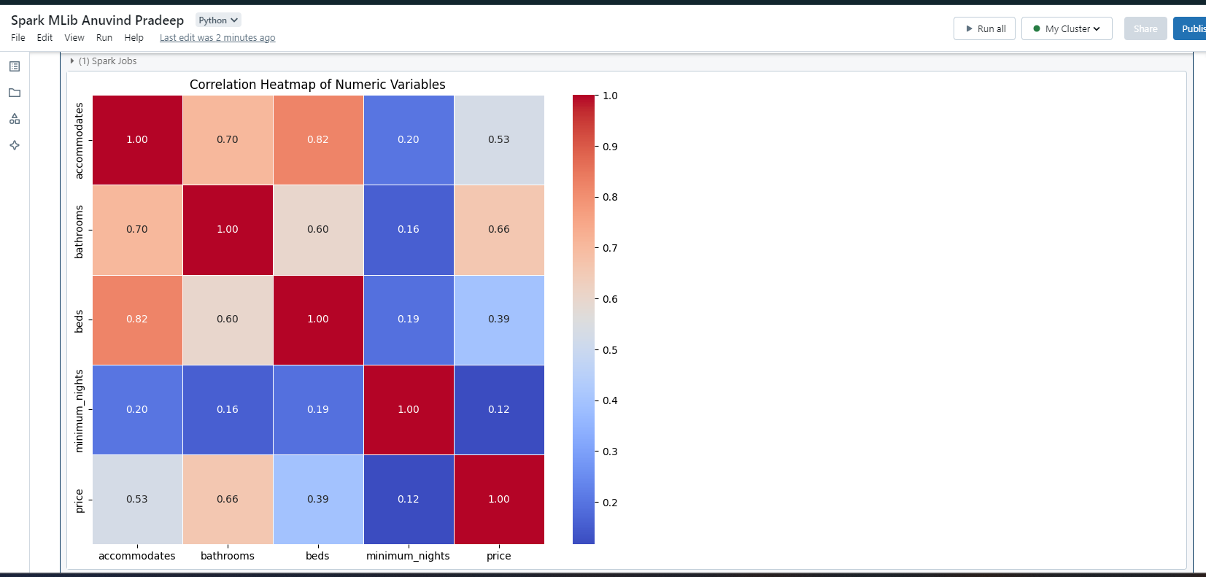
S2. An output statement about the split dataset into training and test data.
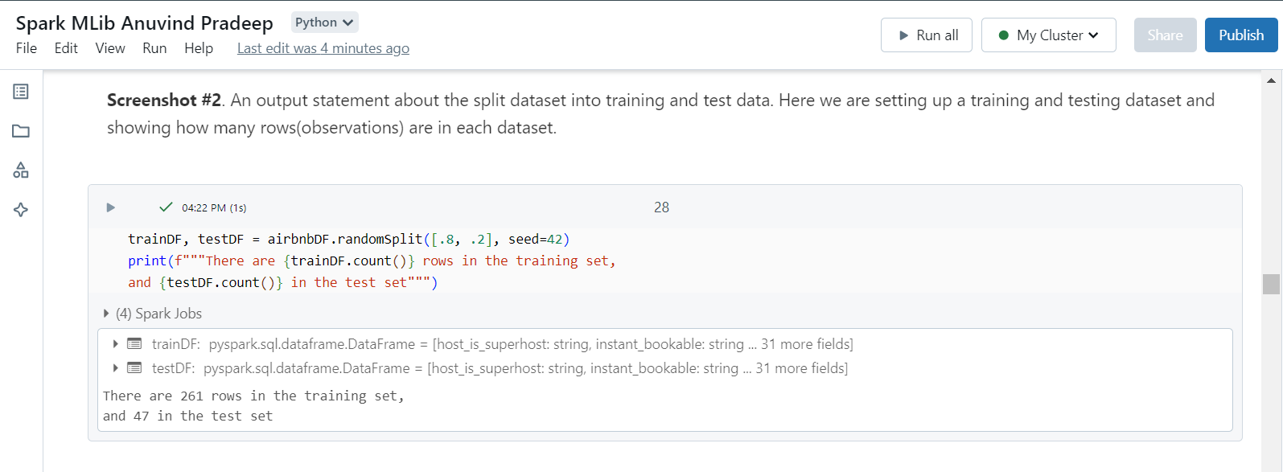
S3. A univariate regression model with one feature changed from the provided example.
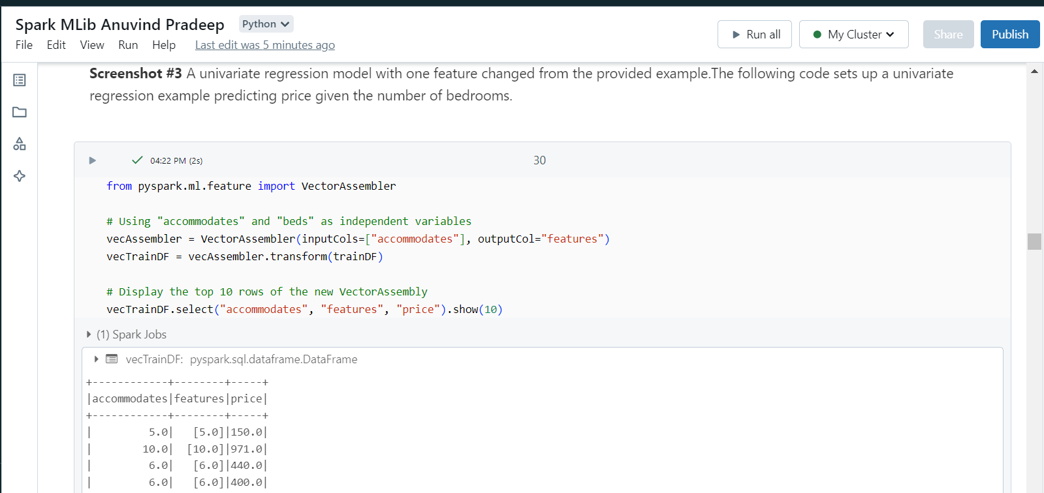
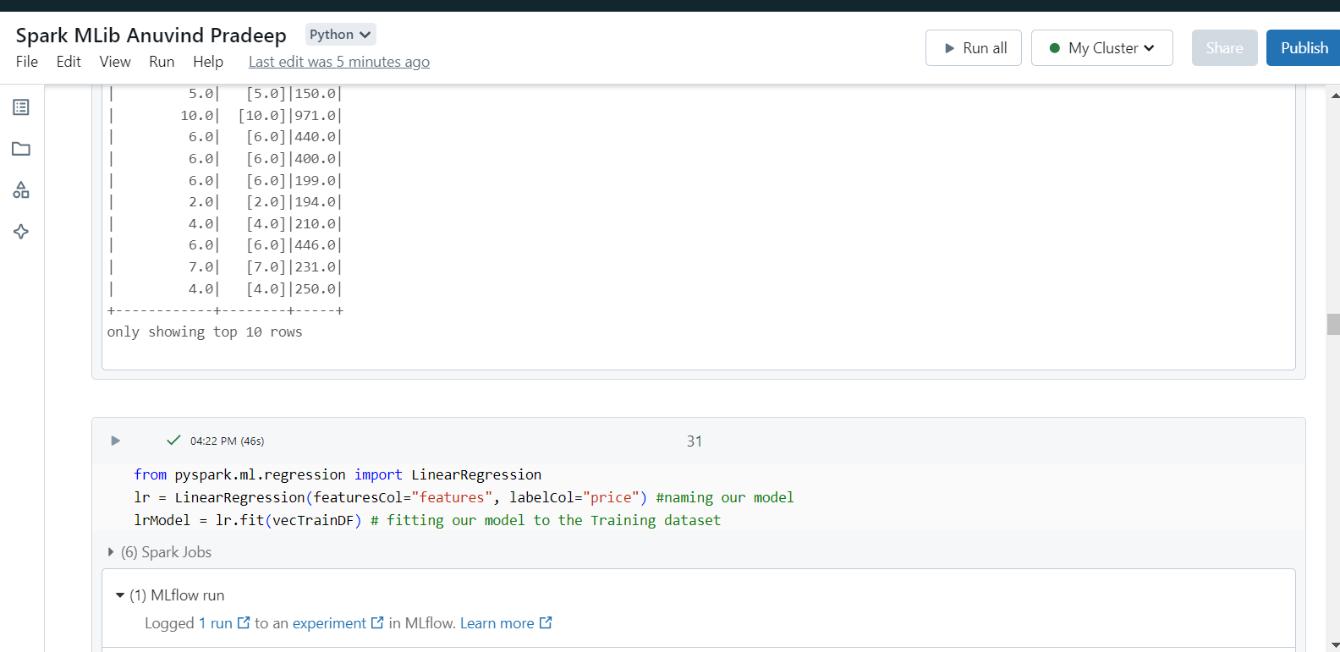
S4. A linear regression line print out showing your variable selection for the univariate model.
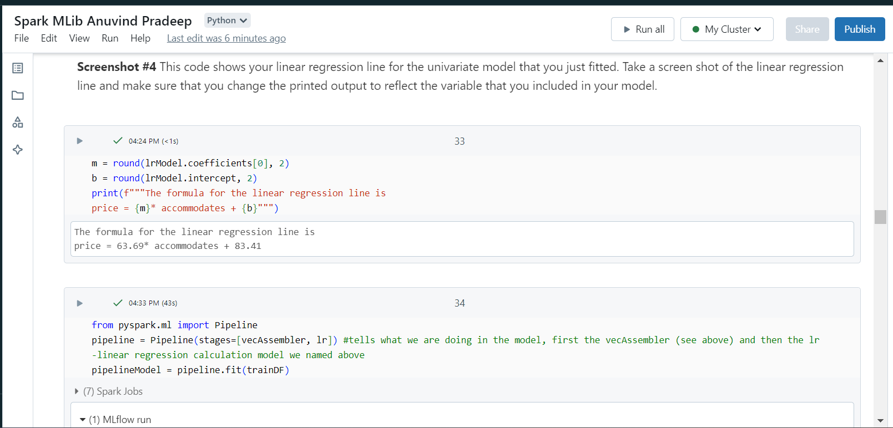
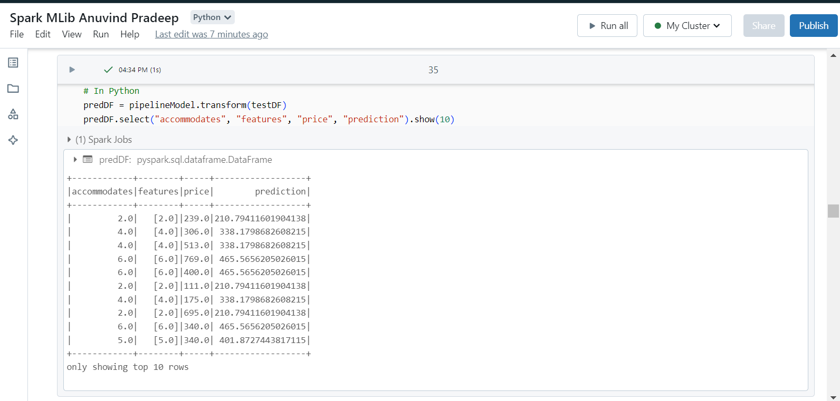
S5. A printout of RMSE and R^2 values for your univariate model.
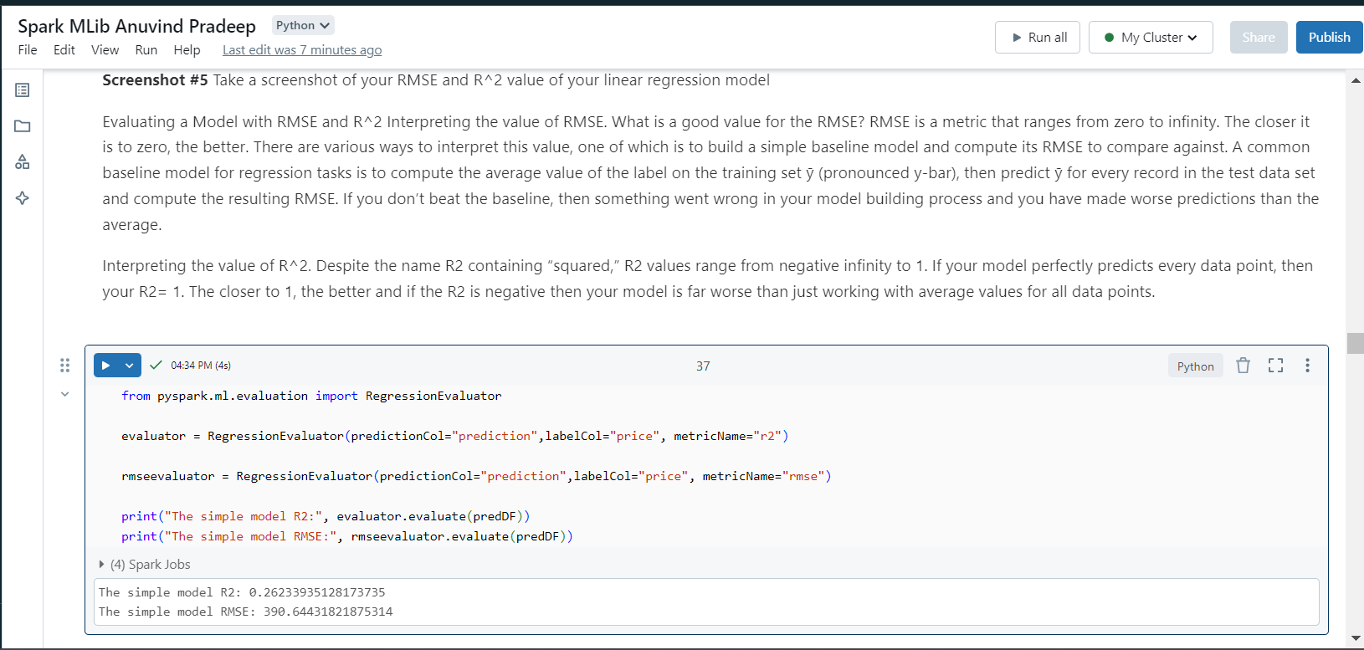
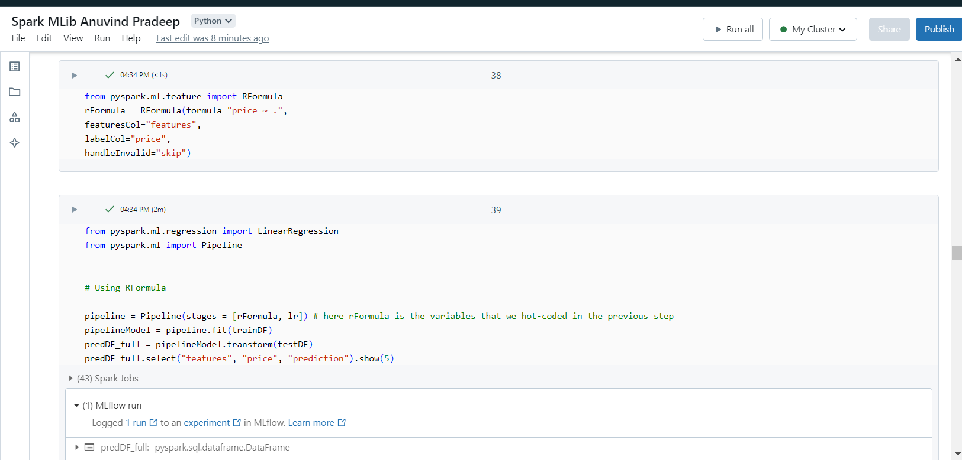
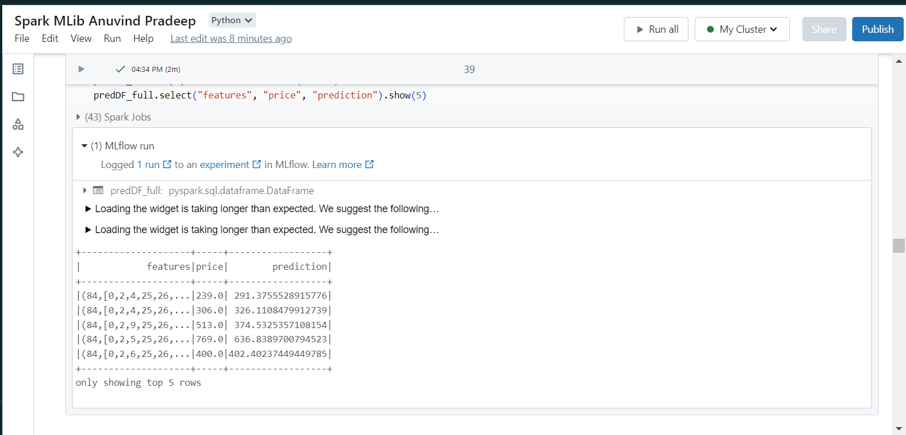
S6. A printout of RMSE and R^2 values for the full model.
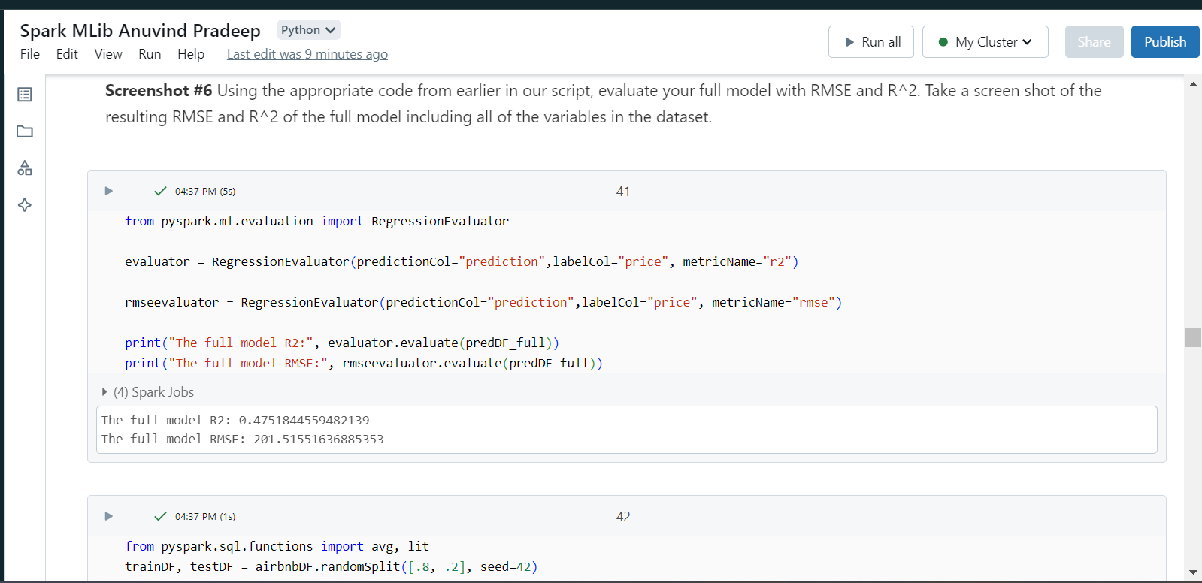
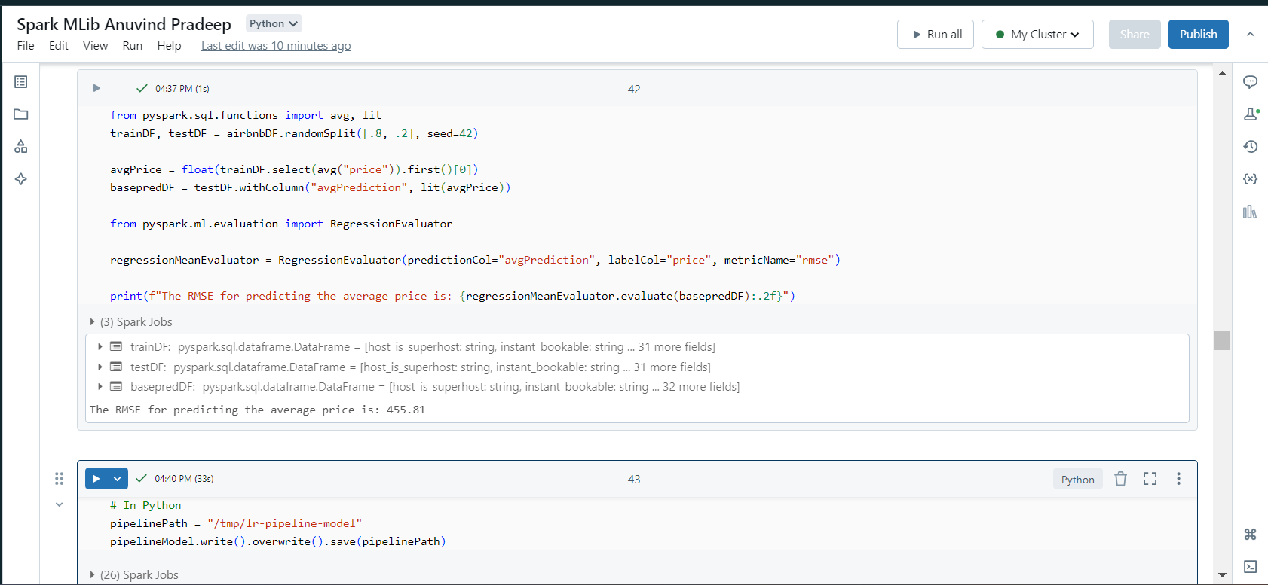
S7. Bonus: An output of a logistic regression or clustering on the dataset.
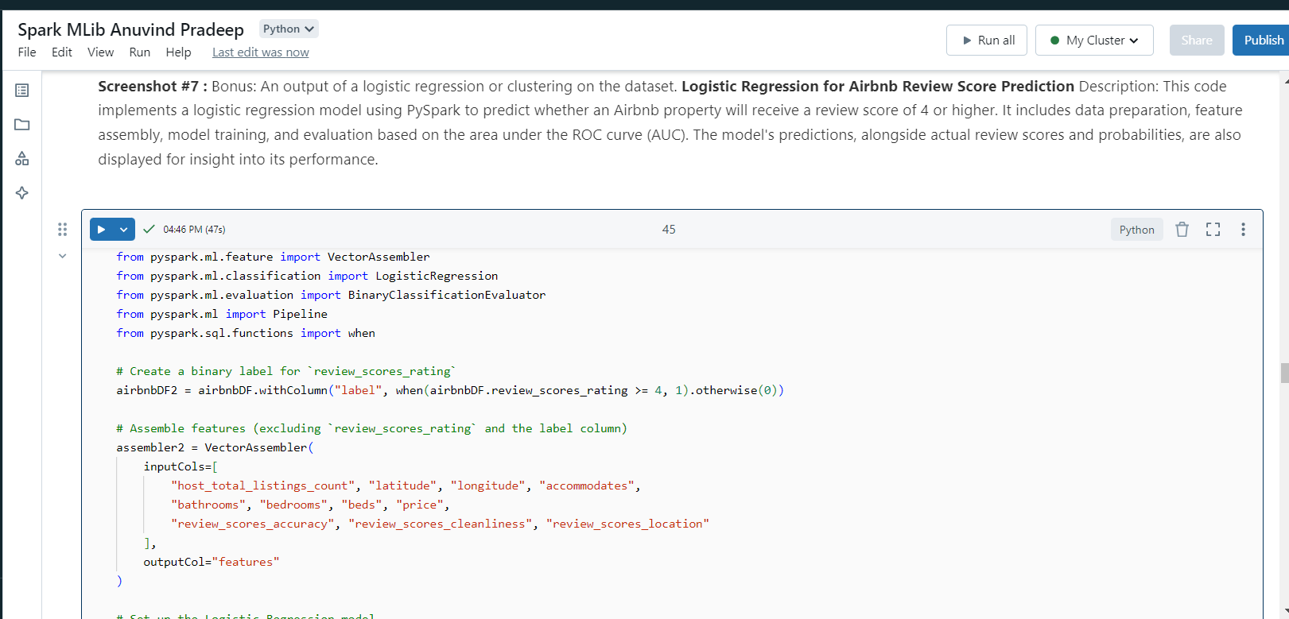
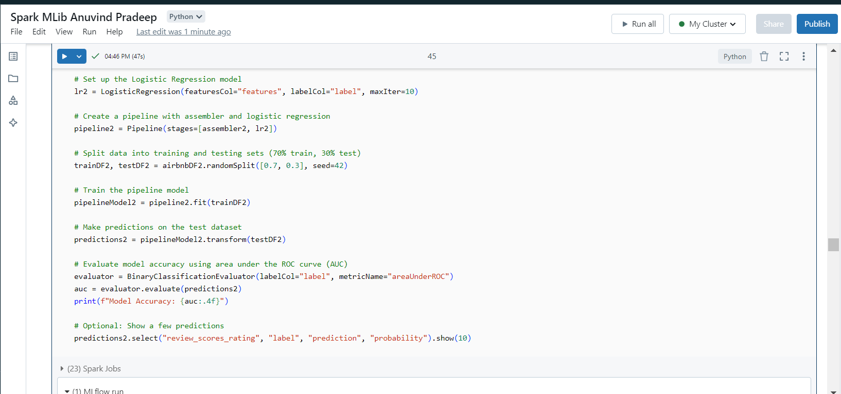
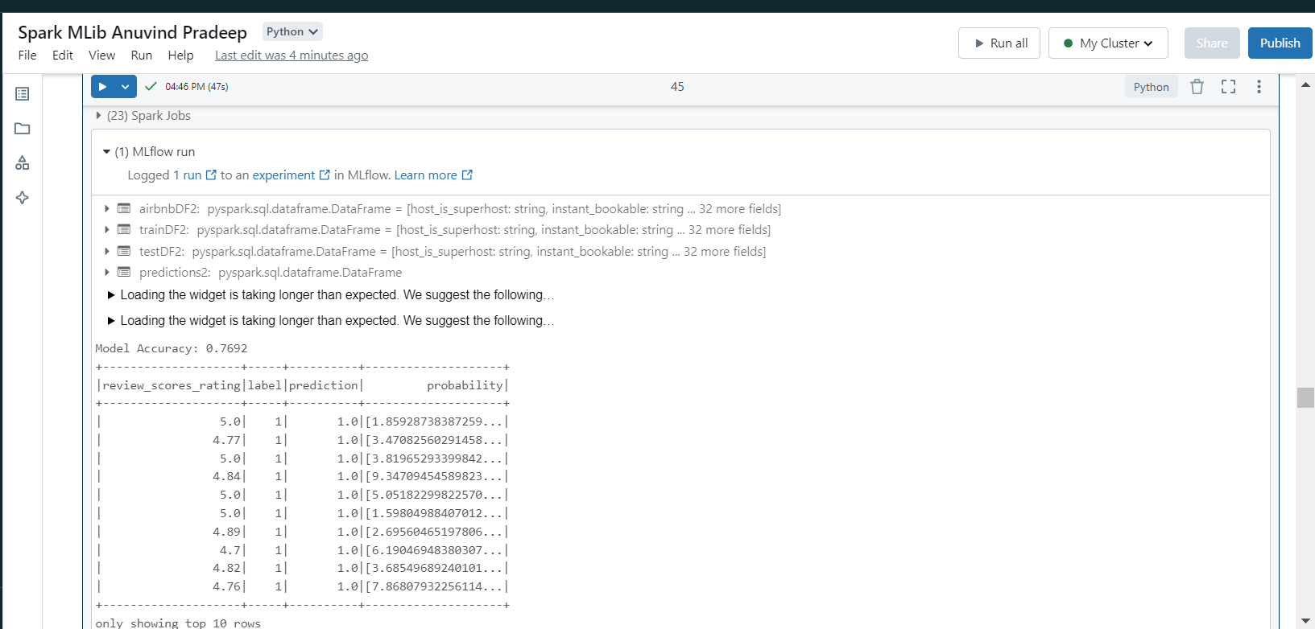
S8. Bonus: A printout of RMSE and R^2 values for the model tested out on data from another city.
The second city I have chosen is:
Berlin, Berlin, Germany

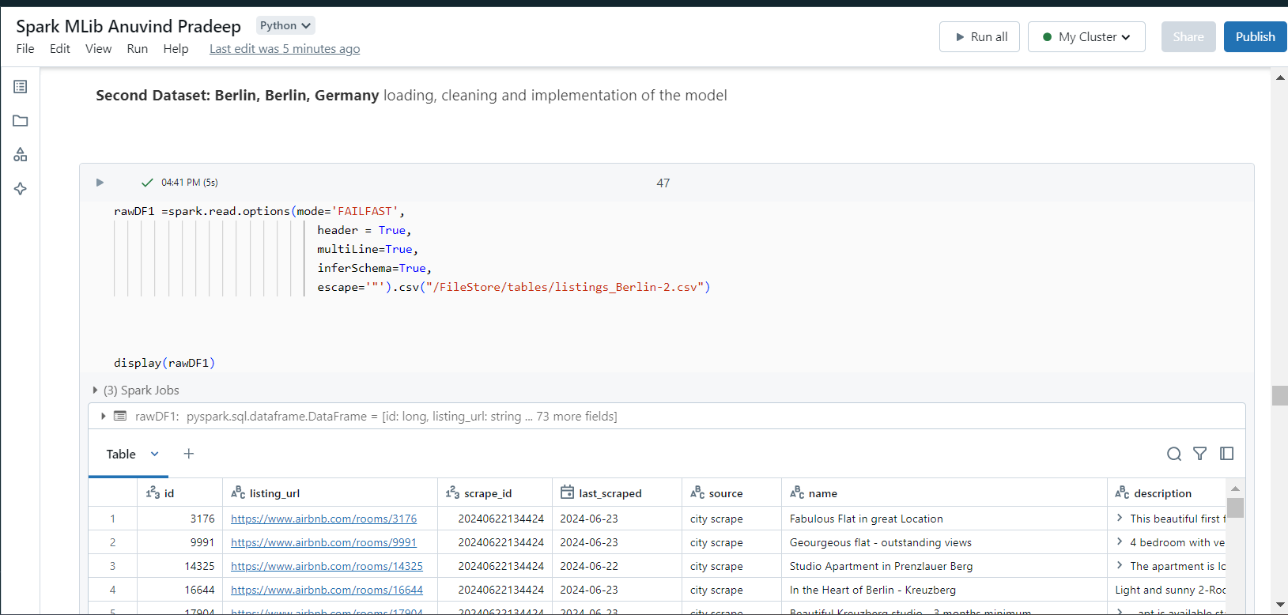
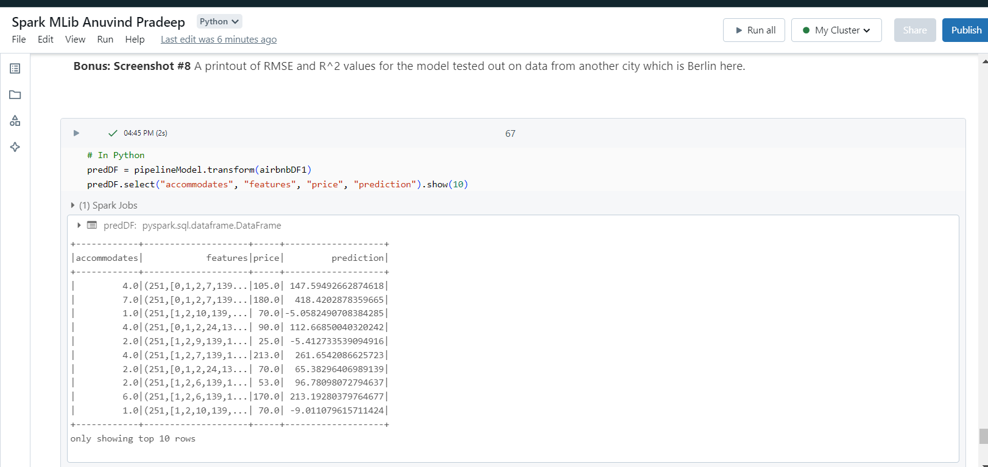
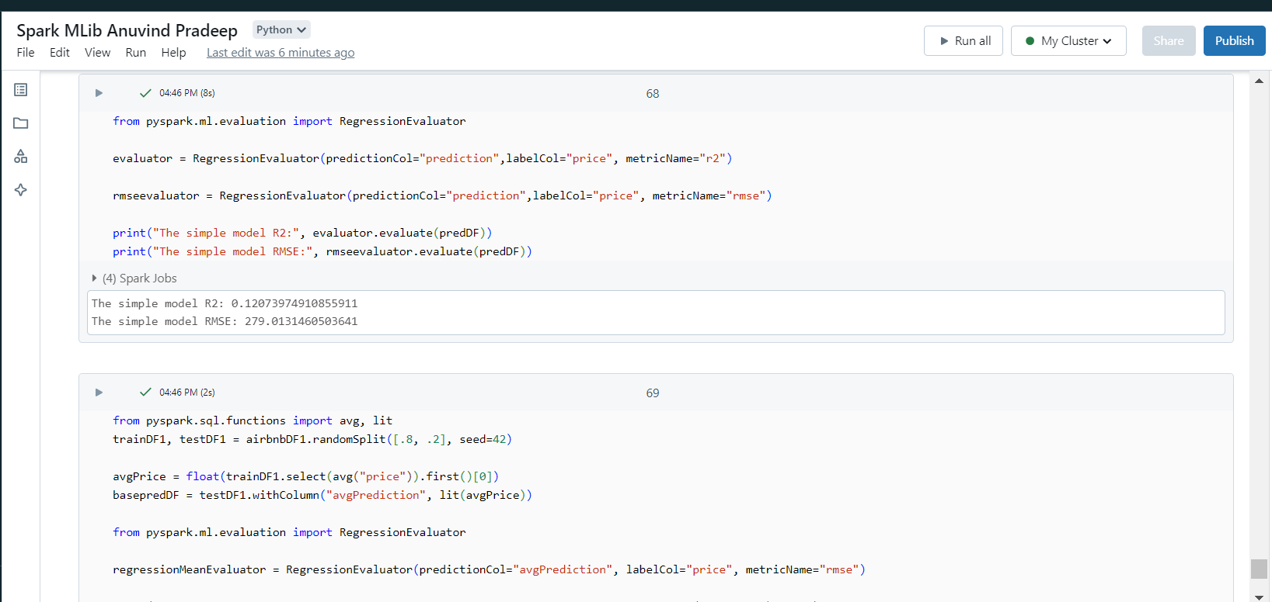
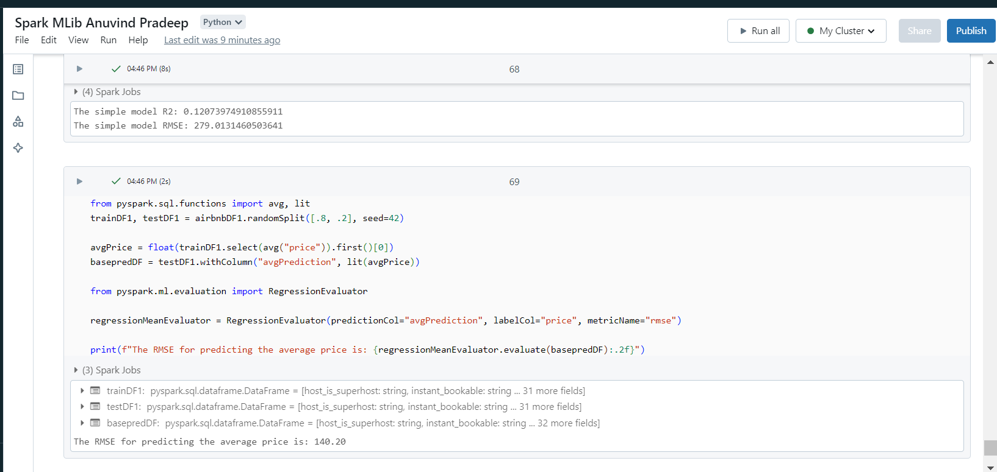

Q1. Through Spark and Databricks you were able to create a basic machine learning prediction model. This is a beginning step to datamining using big data analytics techniques. Use your predictions and equation line to make a business application that interprets the model that you just created. In your own words, describe how the indicators (RMSE and R^2) showed the difference in the two models..
The logistic regression models built for Barossa and Berlin provide valuable insights into rental pricing and property performance. The Barossa model, with an RMSE of 201.52 and an R² of 0.475, demonstrates better accuracy and predictive power for that specific market, making it more reliable for decision-making. In contrast, the Berlin model's higher RMSE of 279.01 and lower R² of 0.12 indicate limited accuracy and a weaker ability to capture the variance in rental prices. This difference arises because each city has unique data patterns; running a model trained on Barossa data on Berlin properties may lead to reduced predictive power and accuracy, as the model doesn’t account for Berlin-specific factors.
For business needs, the Barossa model is more suitable for precise applications like pricing strategy optimization, investment decision support, and targeted marketing within the Barossa market. For instance, the model can guide dynamic pricing adjustments and highlight key features that boost rental prices, supporting hosts in enhancing property appeal. It can also help investors estimate rental income potential in Barossa with greater confidence. However, applying the Barossa model directly to Berlin may produce inaccurate results due to the lower R², so businesses should consider retraining the model with Berlin data. By adapting models to each market’s specific characteristics, companies can make more informed and regionally tailored decisions that drive profitability and customer satisfaction.
References
- https://chat.openai.com/ (I used ChatGPT, a generative AI tool to provide better insights on the business-related question and the tool was instrumental in enhancing the clarity of my explanations.)

